Power Strings
Time Limit: 3000MS |  | Memory Limit: 65536K
Total Submissions: 31634 |  | Accepted: 13175
Description
Given two strings a and b we define a*b to be their concatenation. For example, if a = "abc" and b = "def" then a*b = "abcdef". If we think of concatenation as multiplication, exponentiation by a non-negative integer is defined in the normal way: a^0 = "" (the empty string) and a^(n+1) = a*(a^n).
Input
Each test case is a line of input representing s, a string of printable characters. The length of s will be at least 1 and will not exceed 1 million characters. A line containing a period follows the last test case.
Output
For each s you should print the largest n such that s = a^n for some string a.
Sample Input
abcd
aaaa
ababab
.
Sample Output
1
4
3
Hint
This problem has huge input, use scanf instead of cin to avoid time limit exceed.
Source
Waterloo local 2002.07.01

对于代码中i-next[i]代表了字符串最小前缀且满足能不但的复制得到
原字符串；len%(i-next[i])==0时代表字符串刚刚是子串的整数倍；

若len%(i-next[i])==0匹配时每一次移动的距离i-next[i]是相等的，若不等则只有最后一次不等；

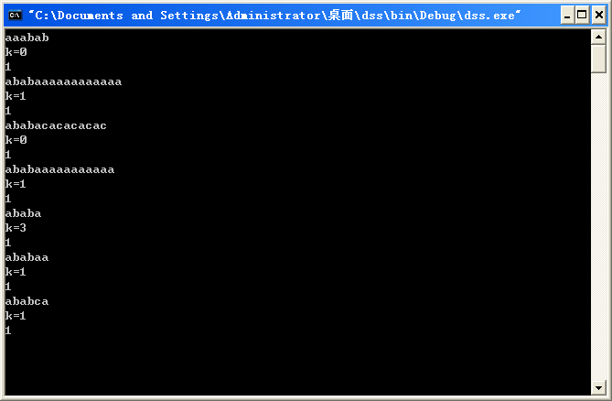

注意是和前缀字符串进行比较 先以aaabab为例 最后一个b不一样 便要用next【5】
但next【5】是零
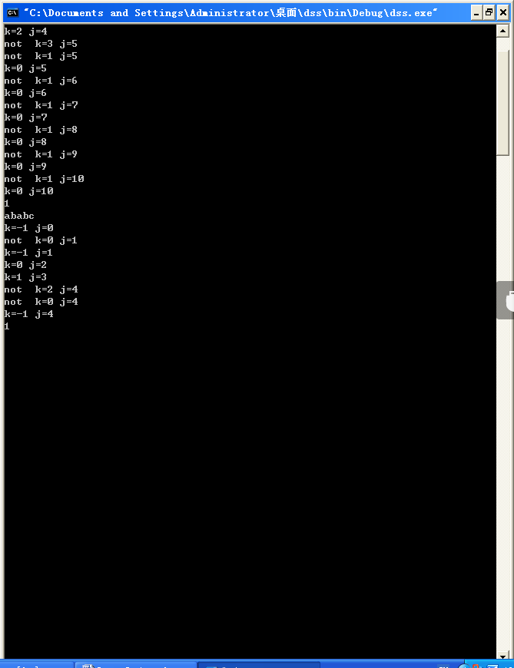
第二个例子 最后一串a里 a和第一个a相同 k便等于1了然后接下来的一个a与b不同便求next【1】=0；因为j此时没变所以一定会回去比较 程序一定不会在k=0 时结束 K此时重复上一个过程 再回到a进行比较 此时又相同了！

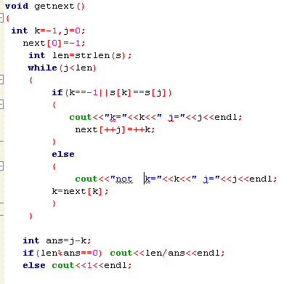搭配上个图

#include <iostream>
#include <cstring>
using namespace std;
char s[1000001];int next[1000001];
void getnext()
{
int k=-1,j=0;
next[0]=-1;
int len=strlen(s);
while(j<len)
{
if(k==-1||s[k]==s[j])
next[++j]=++k;
else
k=next[k];
}

int ans=j-k;
if(len%ans==0) cout<<len/ans<<endl;
else cout<<1<<endl;

}
int main()
{
while(cin>>s)
{
if(s[0]=='.')
break;
getnext();
}
return 0;
}

#include <iostream>
#include <cstring>
#include <string>
#include <cstdio>
using namespace std;

char s[10000001],str[10000001];
int main()
{
int i,j,mark;
while(cin>>s)
{ mark=0;
if(s[0]=='.') break;
int len=strlen(s);bool flag=true;
for(i=0;i<len;i++)
{
for(j=i;j<len;j++)
{
strncpy(str,s+i,j-i+1);
str[j-i+1]='\0';

string s1="\0";//cout<<string(str)<<endl;
for(int k=1;k<=len;k++)
{
s1=s1+string(str);//cout<<s1<<" "<<string(s)<<endl;
if(s1==string(s)) {mark=k;flag=false;break;}
}
if(!flag) break;

}if(!flag) break;
if(!flag) break;
}

cout<<mark<<endl;

}
return 0;
}

#include <iostream>
#include <cstring>
#include <string>
#include <cstdio>
using namespace std;

char s[10000001],str[10000001];
int main()
{
int i,j,mark;
while(cin>>s)
{ mark=0;
if(s[0]=='.') break;
int len=strlen(s);bool flag=true;
for(i=0;i<len;i++)
{
for(j=i;j<len;j++)
{
strncpy(str,s+i,j-i+1);
str[j-i+1]='\0';

string s1="\0";//cout<<string(str)<<endl;
for(int k=1;k<=len;k++)
{
s1=s1+string(str);//cout<<s1<<" "<<string(s)<<endl;
if(s1==string(s)&&k>mark) {mark=k;}
}
}
}

cout<<mark<<endl;

}
return 0;
}

